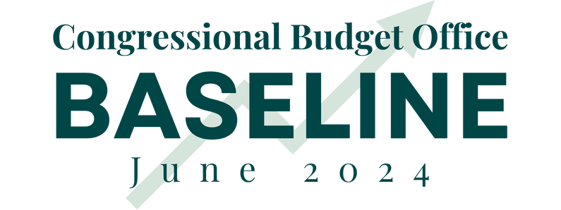

Today, the Congressional Budget Office (CBO) released their updated budget projections for fiscal years (FY) 2024-2034. CBO’s report helps Congress understand the fiscal and economic challenges facing the country. According to the report:

Gross Federal Debt:
- Totals $56.8 trillion (137.3 percent of GDP) in 2034, up from $34.7 trillion (122.7 percent of GDP) now.
FY 2024 Deficit:
- Totals $1.9 trillion, the third highest figure in American history.
- CBO increased their FY 2024 deficit projection by $408 billion or 27 percent compared to February. A major factor is the $145 billion increase to projected student loan spending, attributable to President Biden’s executive actions.
- The FY 2024 deficit is equivalent to 6.7 percent of GDP (the 50-year average is 3.7 percent), which is the highest peacetime figure in American history outside of the 2008 financial crisis and the pandemic. This historically high projection coincides with a 17.2 percent of GDP revenue projection (roughly equal to 50-year average of 17.3 percent). Higher spending, 23,9 percent of GDP compared to 50-year average of 21.0 percent, is primarily to blame.
Ten-Year Deficit:
- Totals $22.1 trillion, greater than all deficit spending by the federal government from 1789 to 2020.
- The deficit increases by 49 percent over the budget window, growing from $1.9 trillion this year to $2.9 trillion (6.9 percent of GDP) in 2034.
Spending:
- Totals $84.9 trillion over ten years.
- Grows from $6.8 trillion (23.9 percent of GDP) in 2024 to $10.3 trillion (24.9 percent of GDP) in 2034.
- CBO projects mandatory spending (including interest) will increase from 74 percent of the budget in 2024 to 78 percent of the budget in 2034.
Mandatory Spending:
  - $51.4 trillion over ten years.
  - Grows from $4.1 trillion (14.5 percent of GDP) in 2024 to $6.4 trillion (15.3 percent of GDP) in 2034.
Net Interest Spending:
  - $12.9 trillion over ten years.
  - Grows from $892 billion (3.1 percent of GDP) in 2024 to $1.7 trillion (4.1 percent of GDP) in 2034.
  - In 2024, interest spending will be the second largest item in the federal budget behind only Social Security.
  - Interest spending has increased by $540 billion or 153 percent in the three years since Biden took office.
  - Interest costs are projected to increase from 9 percent of federal revenue in 2021 to 18 percent of federal revenue in 2024 to 23 percent of federal revenue in 2034.
  - Over the next ten years, for every dollar the federal government borrows, 59 cents will go to paying interest on the national debt.
Discretionary Spending:
  - $20.5 trillion over ten years.
  - Grows from $1.8 trillion (6.3 percent of GDP) in 2024 to $2.3 trillion (5.5 percent of GDP) in 2034.
Revenue:
- Totals $62.8 trillion over ten years.
- Grows from $4.9 trillion (17.2 percent of GDP) in 2024 to $7.5 trillion (18.0 percent of GDP) in 2034.
- Revenue averages 17.8 percent of GDP over the decade, above the 50-year average of 17.3 percent of GDP.
Economic Growth:
- 2.0 percent in 2024.
- 1.8 percent annual average over the next decade.
CPI Inflation:
- 3.0 percent in 2024.
- 2.3 percent annual average over the next decade.
Interest Rates:
- The projected interest rate on 10-year Treasury notes for 2024 has increased from 1.5 percent when President Biden took office to 4.5 percent in CBO’s latest projection.
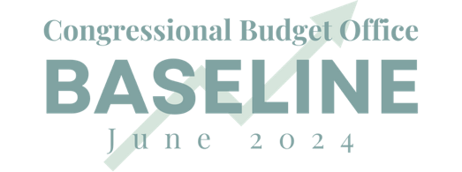
- The 10-year average interest rate projection is 3.9 percent.

